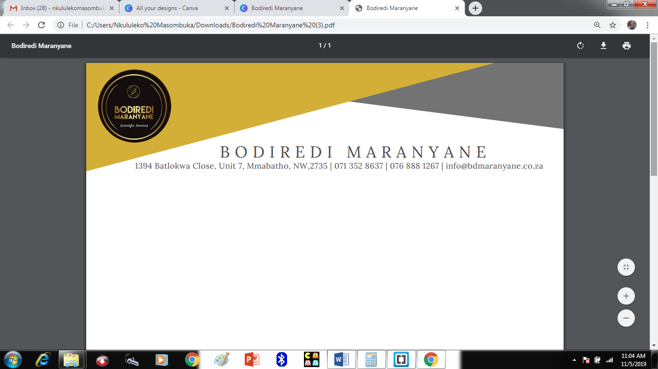 C:\Users\Nkululeko Masombuka\Pictures\Logo\3.jpg

1394 Botlokwa Close, Unit 7, Mmabatho, NW 2735 | [info@bdmaranyane.co.za](mailto:info@bdmaranyane.co.za)

**1. About Us**

Bodiredi Maranyane is an enterprise with a focus on utilization of renewable energy for off grid applications. The off grid applications include street lighting, domestic households, education centres, boreholes, factories, health centres, etc.

The objectives of Bodiredi Maranyane are to contribute to universal access to electricity using renewable energy as a bridging technology for the majority of the poor who cannot afford to pay cost covering prices. In addition, Bodiredi Maranyane aims to contribute towards reducing carbon emissions by promoting renewable (cleaner) technologies for self- sustainability.

Bodiredi Maranyane is registered with Company Intellectual Property Commission (CIPC), registration number: 2019 / 265843 / 07 and is compliant.

**2. Management**

**Managing director**: Thabiso Kgosiemang

Thabiso is a professional Electrical Engineer, accredited by the Engineering Council of South Africa (ECSA) with registration number: 20160481. He holds a Bachelor of Science degree in Electrical Engineering from the University of Cape Town and a Bachelor of Science in Applied Mathematics from North West University (Mahikeng Campus). He is affiliated with the South African Institute of Electrical Engineers (SAIEE), registration number: 15314. He has 7 years of experience working as an Electrical Engineer.

**3. Contact Us**

Email: [info@bdmaranyane.co.za](mailto:info@bdmaranyane.co.za)

Tel: +27 76 889 1267

Cell: +27 71 352 8637

Other information

Facebook:Bodiredi Maranyane

Twitter: @BDMaranyane

**4. Services**

Installation of solar photovoltaic energy systems for the following applications:

* Domestic households
* Education centres
* Health centres
* Street lighting
* Boreholes
* Factories/Plants

**5. Mission**

Our mission is to contribute to universal access to clean, reliable and affordable electricity through the design and provision of customized solutions, efficient and quality service as well as adherence to the highest standards of safety and compliance.

**6. Vision**

Our vision is sustainable development through utilization of renewable energy to conserve the environment and increase access to reliable and affordable electricity for self-sustainability.

**7. Benefits of Renewable Energy**

* Section 12B tax incentive.
* Potentially unlimited supplies and not affected by inflation.
* Clean energy without production of greenhouse gas emissions which leads to environment conservation.
* Renewable Energy can bring power to remote areas due to smaller scale of operations.